Mystic Howl
Choreography

Art list (total: 2 hr)
Bitmap font | only numbers, export from coin symbol | 2

Animation list (total: 146 hr)
Pot (3 skins) | setting | 10
 | Idle (6 levels) | 8
 | Hit (5 levels) | 8
 | Level up (4 levels) | 8
 | Trigger (5 levels) | 8
Bonus (3 skins) | setting | 4
 | srs | 6
 | win | 8
 | idle | 6
Fireball | 3 colors | 6
Collect | setting | 6
 | win | 4
 | idle | 4
Coin | setting | 4
 | idle | 4
 | srs | 4
 | win | 4
Wild | setting | 8
 | Win | 8
 | idle | 6
 | srs | 6
transition |  | 10
Winbox |  | 6

Animation

Pot

Idle
Symbol | 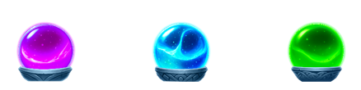
Looping | yes
Duration | 5 sec
Description | 6 levels  Level 1-5 : The liquid and particles (in different colors) increase level by level.  Ref : https://www.pinterest.com/pin/1829656093412682/  Level 6 (during feature) : The crystal floats up, filled with liquid inside, while a colorful light aura flies around it.

Level up
Symbol | 
Looping | no
Duration | 1 sec
Description | 4 Levels  - Level 1-2  - Level 2-3  - Level 3-4  - Level 4-5  - The crystal floats up while particles pour into it, increasing the liquid inside.  Ref : https://www.pinterest.com/pin/121245414962191334/

Hit
Symbol | 
Looping | yes
Duration | 0.5 sec
Description | 5 Levels  - The crystal bounces, and fragments of light spread around it.

Trigger
Symbol | 
Looping | no
Duration | 1 sec
Description | 5 Levels  - Level 1-6  - Level 2-6  - Level 3-6  - Level 4-6  - Level 5-6  - The crystal shakes, floats up, and gathers the surrounding light into itself. Then it explodes the colorful light and rainbow particles (blue, pink, and green).

Scatter(bonus) *3 skins
Khash:“So for scatter, since its 1 scatter, the srs should have 3 variants to suit each pot color”

Win
Symbol | 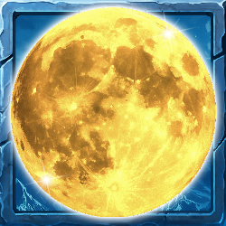 (colors: )
Looping | no
Duration | 1 sec
Description | The moon floats up, and a light aura appears around it (in different colors).

srs
Symbol |  (colors: )
Looping | yes
Duration | 0.5 sec
Description | The moon lands and bounces, releasing a spreading aura of light that shoots outward.

Idle
Symbol |  (colors: )
Looping | yes
Duration | 5 sec
Description | - Subtle movement.  - Purple, blue, and green glows appear around the moon.

Coin

Win
Symbol
Looping | no
Duration | 1 sec
Description | - The coin glows and scale up then spins once  - Explode the light particles and back to the same position

srs
Symbol
Looping | yes
Duration | 0.5 sec
Description | - Lands and bounces  - Light sweep on coin

Idle
Symbol
Looping | yes
Duration | 5 sec
Description | - Subtle movement  - Light sweep on coin

Fireball *3 colors
Symbol
Looping | yes
Duration | 5 sec
Description | Golden color and the color match with the pot’s color

Collect

Win
Symbol
Looping | yes
Duration | 1 sec
Description | - fx from coins running in the center of the Collect symbol  - light sweep  - the paw scale up and glow up

Idle
Symbol
Looping | yes
Duration | 5 sec
Description | - Light randomly glows out on the runes  - Paw pulsing bigger + Light sweep on the paw  - Light randomly glows from the runes.  The paw pulses larger, and a light sweep passes over it.

Wild

Win
Symbol | 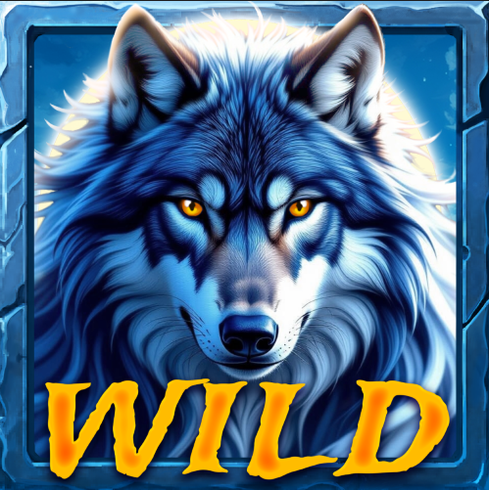
Looping | yes
Duration | 1 sec
Description | - A light sweeps across the WILD text.  - The wolf appears and scales up.  - eyes change to a golden color.  - Particle effects explode around it.

Srs
Symbol | 
Looping | yes
Duration | 0.5 sec
Description | - It bounces as little particles float upward.  - light sweeps on the WILD text.

Idle
Symbol | 
Looping | yes
Duration | 5 sec
Description | - Subtle movement  - Sparkles slowly float up

Transition
Looping
Duration | 1-2 sec
Description | - Aurora effect cover the background

Winbox
Looping | yes
Duration | 1-2 sec
Description | - Rainbow effect

